For a complete portfolio of all MAP reports and glossary of terms: https://cmsmap.weebly.com/reports.html

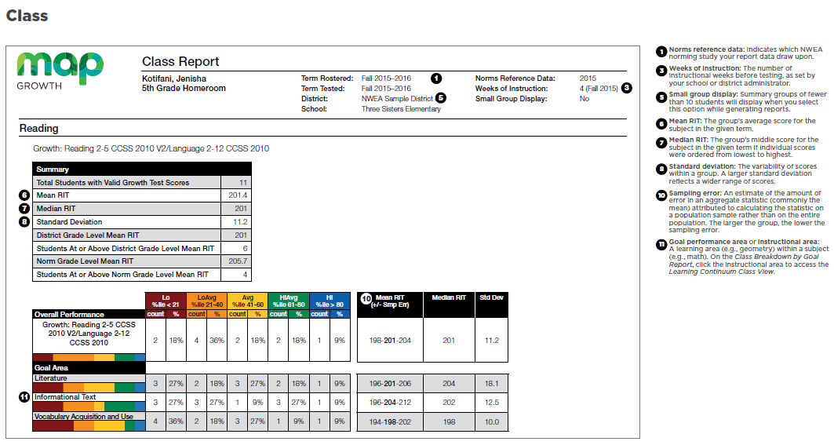
Mean = class average
Median = middle score
Standard Deviation = range on either side of mean
An equivalent report for administrators is the Grade Report.
#8. Standard deviation is how big your bell curve is. It tells the diversity of the students. The higher the number, the more differentiation is needed, because their academic skills are different. If the number is 10 or less, your students’ are more alike in their academic skills. 68% of students fall within the bell curve range
#10. Compare the mean RIT scores. You can see which goal area is a strength or a weakness for your class. Using the above goals, Vocabulary Acquisition and Use is a class weakness.
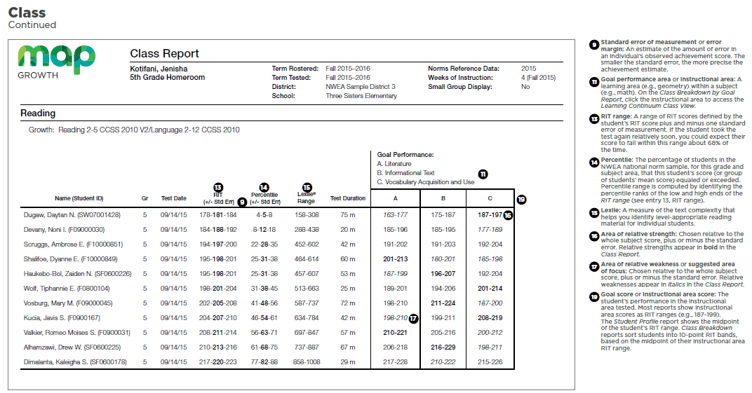
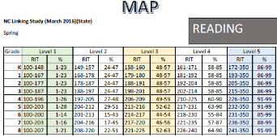
Numbers in Bold indicate a strength sub-goal area for students
Numbers in Italics indicate a weakness sub-goal area for students

Use the NC Linking Study to see, by percentage, what achievement level students are expected to fall into on their EOG (i.e., the top 3 students, Drew, Noni and Ambrose, are predicted to be at achievement level 1).
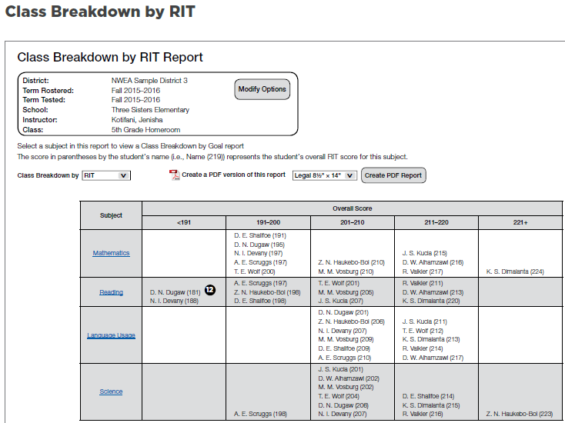
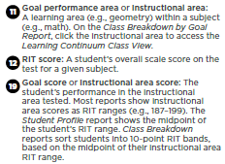
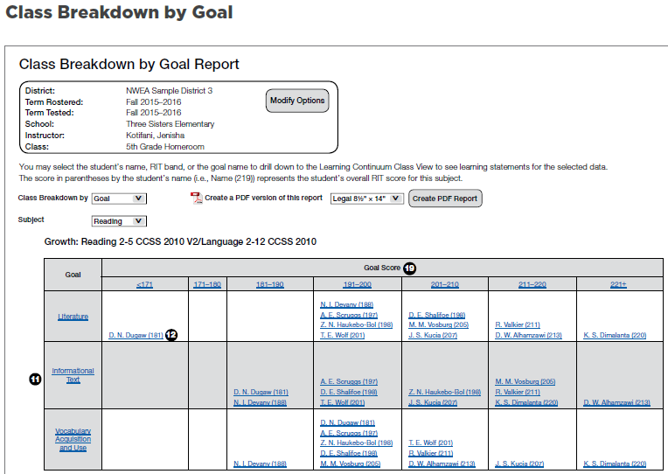
RIT Band
The Class Breakdown groups students. It can be filtered by Goal
(on the left) or by RIT (on the right) (and can even be used to schedule students).

The number in parenthesis, after the student name, is the overall RIT. A student’s name will appear in several RIT-band groupings based on their strengths and weaknesses in sub-group or strand (by goal) or subject (by RIT).
Click on subject or goal to see the Learning Continuum for all students. Click on a student to see the Learning Continuum for that student.

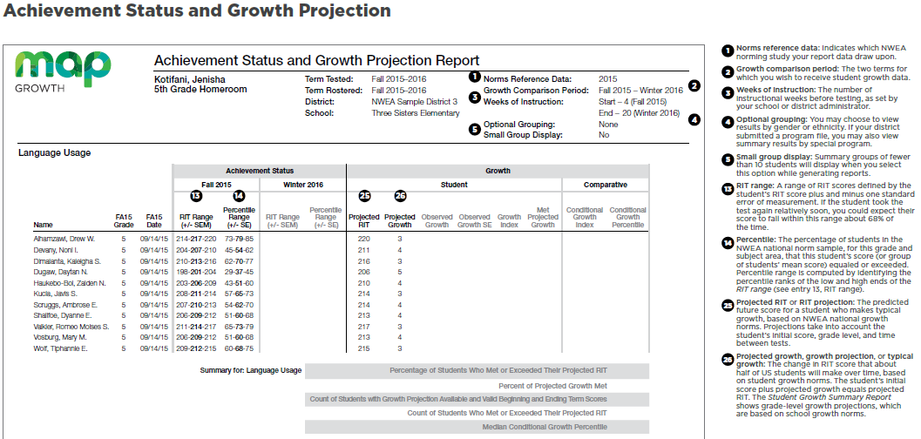

The Achievement Status and Growth Report is used to predict how much your students should grow.
Looking at the first student, Drew’s projected growth is 3 RIT points by the winter screener. The report is filtered for fall - winter. If Drew grows only these 3 RIT points, he will stay at the 79th percentile.
Teachers will want to see students grow more than what is projected to move students to a higher percentile level and from one proficiency achievement level to another.
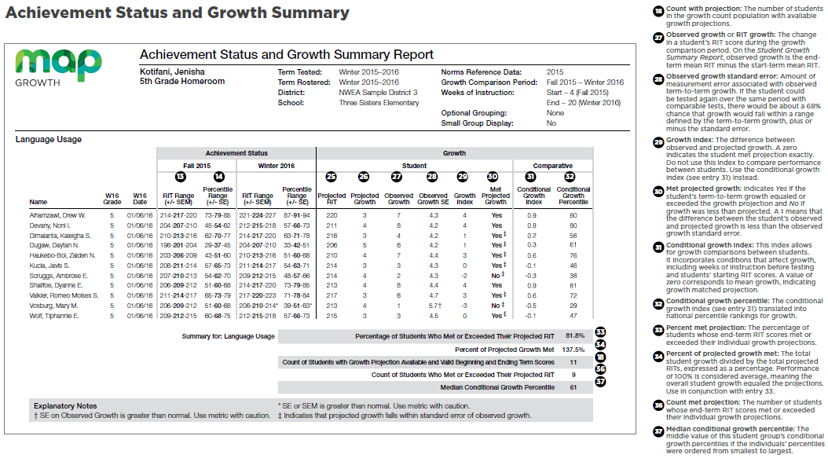#27 Observed Growth is how much the student actually grew.
#29 Growth Index is how much the student missed or exceeded their growth projection.
#31, #32 Conditional Growth Index and Conditional Growth Percentile compares student growth to other students, nationally. This Conditional Growth Index number can be used to compare the strength of a student’s growth to their peers within the same classroom. It measures the strength of the growth with all students on the same bell curve. A teacher will want to see the Conditional Growth Percentile for an individual student at 50-55% or better.

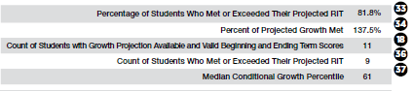

#33 – The typical percentage of students who meet or exceed their projected RIT is 50-55%. This number indicates the percentage of students meeting growth projections. This predicts if the students are on track to meet proficiency on their EOGs.
#34 – This number indicates the total growth of the class. The total growth of the class is typically 100. It is calculated by taking the Observed (Actual) Growth for all students, then dividing by the Projected Growth for all students. If the growth is more than 100%, it indicates that some students grew a lot and are pulling up your number. If the growth is listed at below 100%, it indicates that some students did not grow to expectation and are pulling down your growth number.
#37 – The typical Median Conditional Growth Percentile is 50-55%. We would like to see this number higher than typical as it indicates that the students in the class are on track to make their growth projections.

Orange-Low achievement but growing, making more than a year’s worth of growth, achievement gap is closing. Moving towards proficiency.
Green-YAY! This is where you want students, but don’t forget to continue challenging them so they can continue to grow
Yellow – Students in this quadrant are high achievers with low growth. These students would benefit from being challenged more. At proficiency but may fall behind.
Red- DANGERZONE – Low achievement, low growth, achievement gap is widening.
You can filter your report here.

You can set your Achievement Percentile using the NC Linking Study Chart Percentile. You adjust the bar, using the NC Linking Study, to reflect Grade Level Proficiency. The students that fall on or around the Achievement Percentile bar are your students just as likely to be non-proficient as they are to be proficient.
Achieving at the 50th percentile does not get you to Grade Level Proficiency (GLP) or College and Career Ready.

