MAP - Useful Teacher Reports
by the Data Use for School Improvement Team

To access the reports below:
- Login to teach.mapnwea.org
- Under “View Reports”, click “MAP Growth Reports”

Report | Description | Application
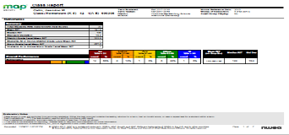  1. Class Report | This report provides an overview of the current status of the student’s skill in each subject area. You can find both whole group and individual student information in this report. | Teachers can use this report to:  - Compare their class’s overall performance with NWEA national averages.  - Compare goal areas- the report shows strengths or areas of need as a class.  - Use individual student performance data to plan enrichment or interventions for students who score in high or low percentiles.
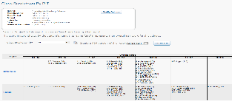  2. Class Breakdown Report | This report provides a class breakdown of small groups of students who are ready to learn at a similar instructional level. | Teachers can use this report to:  - Plan instruction for small groups .  - Monitor using formative assessment strategies.  - Move students from one group to the next as they progress.
3. Learning Continuum  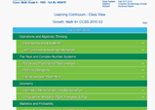 | The Learning Continuum shows the learning statements that groups of students are ready to be taught. | Teachers can use this report to:  - Plan instruction that engages every learner at his/her level of readiness.
4. Achievement Status & Growth Report  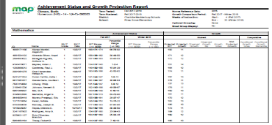 | This report provides a snapshot of students’ MAP performance and a Growth Report, Projection Report, or Summary Report. | Teachers can use this report to:  - Look ahead to see how their students might perform on a future MAP assessment and in goal setting with students.  - See students’ actual performance on a MAP assessment including growth data for individual students and the class as a whole; it can be used to compare class achievement and growth to normative data.
5. Achievement Status & Growth Summary with Quadrant Chart  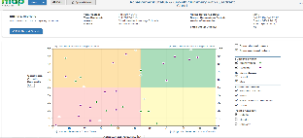 | The ASG Summary with Quadrant Chart is color-coded and shows data in a quadrant chart and table. | Teachers can use this report to: (note need 2 testing terms to use this report)  - Quickly see students’ growth from fall to winter, fall to spring, spring to spring, etc  - Visualize students' achievement and growth. It's also interactive, allowing teachers to change their selections and see updates in real time.  - Compare student growth with national norms (this report can be filtered- see right side of report). Use this report to prioritize based on students’ needs.
6. Student Profile Report  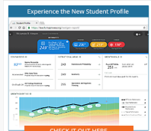 | This report provides information on a student’s past, current and projected MAP performance and growth. | Teachers can use this report to:  - Make a quick comparison of a student to national normative student data.  - Develop a personalized learning path for the student.  - Pinpoint relevant standards to focus intervention or enrichment supports.  - Monitor student growth.  - Set growth goal with students in the live report.
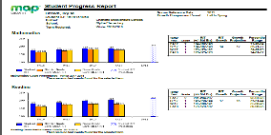  7. Student Progress Report | This report shows the amount of progress a student has made and their academic strengths and weaknesses.. | Teachers can use this report to:  - Have discussions with students, parents, and other school personnel that need to know information about the student’s academic performance in parent teacher/ student conferences and IEP/EC/504 meetings.  - Send home with progress report/report cards..
8. Student Goal Setting Report  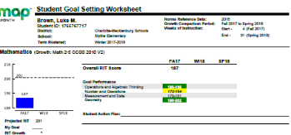 | This report shows individual student goal performance, projected RIT score, and breakdown of academic strengths and weaknesses. | Teachers can use this report to:  - Set learning goals with students in either 1-on-1 conferences or as whole class. As a group, teachers can give each student an individual goal sheet and then walk the class through interpreting the data, setting goals and creating action plans for themselves.

For a complete portfolio of all MAP reports and a glossary of terms: https://cmsmap.weebly.com/reports.html

Additional Resources:
- MAP 2015 Normative Data- Student Status Norm & Student Growth Norm
- NC Linking Study- March 2016

October 2018

